Chapter 4:

# Methodology

## 4.1. Method

SCRUM is the chosen methodology to help control and organise the development of the project. This method is based upon the principles of the Agile Manifesto, along with its own set of techniques. It provides tremendous flexibility and adaptability for the development of the application. This is a particular point as to why SCRUM was chosen because it is likely that there will be at some point a delay as there are many concepts being learnt for the first time and other work being done simultaneously.

As Verheyen, G. (2013) points out, SCRUM is not a strict process that has obligatory and exhaustive steps. Instead there are proposed techniques that is left for the team to decide whether or not to opt. This is brought up as this project will be using SCRUM as its basis, however, there has been some additional decisions that are not particularly part of the SCRUM framework that will disclosed in the following paragraphs.

### SCRUM Approach for Project

It has been decided that the total project sprints will be divided in these stages: Front-end, Back-end and Machine Learning. All of these contain parts of the requirements that are of great importance (the MoSCoW “must” requirements). Therefore, the idea behind this method is that in the worst-case scenario the end application will contain all of the “must” requirements. Anything else will be an application with additional features, which would improve the User Experience (UX) and the usages for the software.

Each stage is comprised of a number of sprints. Each sprint will follow roughly conventional SCRUM sprint protocol, Figure 1 gives and illustrative representations as to what comprises each sprint and what exactly does each step of the sprint mean.

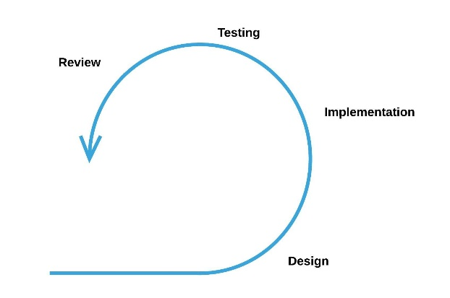Figure - SCRUM Sprint

Table - SCRUM Sprint Steps

|  |  |
| --- | --- |
| SCRUM Sprint Step | Description |
| Sprint Backlog | **Requirements, from Chapter 2, that are related to the stage name are selected to be completed within the sprint**.  This stage formalizes the specific tasks that need completion. |
| Planning & Design | Focuses on how the current stage will be implemented. Therefore, will have a series of diagrams, sketches, charts, or other relevant planning or designing techniques that have been used to condensate the implementation process. |
| Implementation | Overviews the key implementations, in general will consist mainly around code. This is conveyed through snippets of code and explain the chosen approaches/techniques.  This stage highly focuses on the sprint backlog being developed and completed. |
| Testing | Testing that the program functions adequately. Regardless, most emphasis on the testing will surround that the sprint backlog has been properly implemented. |
| Review | At the end, some observations are left for later development and potential comments that can be reused in “Project Evaluation” chapter. |

Overall, the project will have the following development:

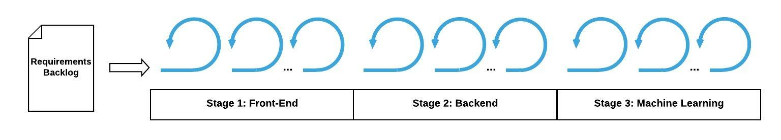Figure - Project SCRUM Development